

NAME: MARYAM ILYAS
SEAT NO: B23110106027
YEAR: BSSE-II(4TH SEMESTER)
COURSE NAME: DATABASE MANAGEMENT SYSTEMS
COURSE NO:SE-452
PROJECT: DIGITAL WALLET SYSTEM
SUBMITTED TO: SIR ASAD

DIGITAL WALLET SYSTEM:
DATABASE DESIGN OVERVIEW (PostgreSQL)
The Digital Wallet System employs a backend-focused architecture where all core functionalities are implemented at the database level. PostgreSQL is used as the primary database management system to ensure secure, reliable, and efficient processing of financial transactions.

- Rationale for Using PostgreSQL
PostgreSQL was selected due to its strong support for:
- ACID-compliant transactions, essential for accurate financial operations
- Advanced constraint management such as foreign keys, check constraints, and unique keys
- Triggers, views, and stored procedures for automating wallet updates, validating operations, and maintaining logs
- Scalability and concurrency control, suitable for handling multiple transactions simultaneously
These features enable the system to maintain high data integrity while supporting real-world digital wallet workflows.

- Database Design Approach
The database schema was designed using standard relational modeling principles, ensuring:
- Third Normal Form (3NF) compliance
- Clear separation of entities
- Minimal redundancy
- Strong referential integrity
The core entities include:
- Users
- Wallets
- Transactions (payments, transfers, refunds, top-ups)
- Merchants
- Offers and Cashback Rules
- Complaints and Support Records
- Administrative Logs
Each entity is linked using well-defined primary and foreign keys to support secure data flow across the system.

- Functional Role of the Database
The PostgreSQL database is responsible for:
- Handling user authentication and storing encrypted credentials
- Maintaining wallet balances and ensuring correctness through automated triggers
- Recording every financial transaction with timestamps and unique references
- Managing merchant profiles and settlement-related data
- Logging administrative activities for monitoring and auditing
- Storing user complaints and tracking their resolution status
All business rules, including validation, balance updates, cashback calculations, and transaction logging, are enforced at the database logic level.
- Implementation and Validation Without UI
In accordance with the project requirements, no user interface (UI) was developed.
All functionalities were built and tested directly through:
- SQL queries
- Stored procedures
- Database triggers
- Schema constraints
- Data manipulation operations within PostgreSQL
This approach ensures that the system's backend logic and data integrity mechanisms are thoroughly implemented and validated without relying on any graphical interface.

SCOPE OF THE PROJECT
The Digital Wallet System is designed to provide a secure, efficient, and user-friendly platform for managing digital financial transactions. Its scope includes all essential operations required for a modern e-wallet, such as user authentication, balance management, payments, transaction tracking, fund transfers, and administrative monitoring. The system focuses on maintaining accurate data records, ensuring secure communication between modules, and supporting transparency in user activities.

1) Functional Scope:
a) User Registration & Authentication
The system allows new users to create an account by providing essential details such as name, email, mobile number, and password. Secure login facilities ensure that only authorized users can access the wallet.

b) Wallet Management
Each registered user is assigned a dedicated wallet. The system maintains the wallet balance, supports top-ups, and tracks all changes made to the wallet amount.

c) Payments & Fund Transfers
Users can make payments to merchants, transfer money to other users, and request payments. These financial operations automatically update the wallet balance while ensuring data accuracy.

d) Transaction Management
All transactions—wallet top-ups, transfers, payments, refunds—are recorded systematically. Users can view transaction history with timestamps, statuses, and reference IDs.

e) Merchant Module
Approved merchants can accept digital payments through the application. The system tracks merchant details, transactions, and settlement information.

f) Offers & Cashback
The system supports promotional offers, cashback rewards, and discount coupons. These features apply automatically during eligible transactions.

g) Administrator Controls
- An admin panel allows the administrator to:
- Manage users and merchants
- Verify complaints
- Monitor transactions
- Review reports for security and auditing purposes

h) Support & Complaints
Users may raise issues or complaints which are recorded and assigned to the support team. Admin can view and update their status.

2) Technical Scope:
The project emphasizes:
- Relational database design and normalization
- Secure storage of user information and financial records
- Maintenance of foreign key relationships across entities
- Handling of concurrent transactions without loss of data
- Implementation of constraints, triggers, and SQL logic

3) Out-of-Scope / Limitations:
To keep the project academically focused, the following areas are not included:
- Real-time integration with bank APIs or payment gateways
- Mobile application development or UI creation
- Encryption algorithms beyond basic password hashing
- Real money transactions (system uses simulated data)
- Multi-currency support

4) Target Users:
- Individual users wanting to make digital payments
- Merchants accepting digital transactions
- System administrators managing platform operations

5) Future Scope:
The system can be extended with:
- UPI and banking API integration
- QR-code based payments
- AI-based fraud detection
- Budget analysis and spending insights for users
- Multi-platform mobile applications

ER DIAGRAM DESCRIPTION
The Entity–Relationship (ER) Diagram of the Digital Wallet System provides a structured visual representation of all data components involved in the application. It illustrates the major entities, their attributes, and the relationships linking them together. The diagram helps in understanding how information flows within the system and ensures that the database is logically organized before implementation.

The ER model for this system contains seven major entities:
- User
- Wallet
- Beneficiaries
- Transaction
- PaymentMethod
- KYC_document
- Admin
Additionally, it includes associative relationships that connect these entities in a clear and meaningful manner.

Entity Descriptions:
1. User
The User entity stores details of every individual registered in the system.
Key attributes include UserID (PK), FullName, Email, PhoneNumber, Password, and CreatedDate.
Each user is linked to exactly one wallet and may perform multiple transactions.

2. Wallet
The Wallet entity maintains financial information for each user.
Important attributes include WalletID (PK), UserID (FK), Balance, and LastUpdated.
A single user owns one wallet, and each wallet records a history of updates through transactions.

3. Beneficiaries
The Beneficiary entity manages the details of individuals or organizations designated to receive funds or benefits from a system user. Attributes typically include BeneficiaryID (PK), the beneficiary name, beneficiary_phone, added_on, UserID (FK) of the person who added them. This entity is crucial for enabling secure and accurate transfer of funds to pre-approved recipients, often used in recurrent payment or transfer scenarios.

4. Transaction
The Transaction entity records every financial activity performed in the system.
Attributes include TransactionID (PK), WalletID (FK), MerchantID (FK), Amount, TransactionType, Timestamp, Status, and ReferenceCode.
Each transaction is linked to one wallet and, if applicable, one merchant.

5. PaymentMethod
The PaymentMethod entity stores details of different modes through which users can add or use funds (such as Credit Card, Debit Card, UPI, or Net Banking).
Attributes include MethodID (PK), UserID (FK), MethodType, ProviderName, and AccountReference.
A user may register multiple payment methods.

6. KYC Document
The KYC Document (Know Your Customer) entity stores the documentation provided by a user to verify their identity and comply with legal and regulatory requirements. Attributes include kyc_ID (PK), UserID (FK), DocumentType (e.g., Passport, Driver's License, Utility Bill), document number, uploaded date, and a VerificationStatus. This entity is vital for ensuring the legitimacy of accounts, preventing fraud, and adhering to Anti-Money Laundering (AML) regulations.

7. Admin
The Admin entity stores data for system administrators responsible for monitoring and managing operations.
Attributes include AdminID (PK), Name, Email, Password, and Role.
Admins oversee user activity, merchant registration, and system reports.

NORMALIZATION PROOF:
Normalization is the process of organizing data in a database to reduce redundancy and improve data integrity. For the Digital Wallet System, the tables were constructed through systematic normalization, ensuring that each entity is structured efficiently and without anomalies.
Below are the steps from Unnormalized Form (UNF) to First (1NF), Second (2NF), and Third Normal Form (3NF).

UNNORMALIZED FORM (UNF)
Before normalization, data for users, wallets, and transactions may be stored together in a single table such as:

User  Name | Email | Phone | Wallet  Balance | Payment  Methods | Transactions
James  Paul | james.paul@gmail.com | 9876543210 | 1500 | UPI: james@upi, Card: 8742 | (TXN784512, $1200, TechBazaar), (TOPUP1122, $500, —)
Sara Thomas | sara.thomas@yahoo.com | 9123456780 | 850.50 | Card: 5521 | (TXN998123, $650, GreenMart), (CBK202, $100, Cashback)

Problems:
- Repeated transaction values
- Multiple payment methods stored in one cell
- Repeated merchant names
- Nested records → violates atomicity
- Severe redundancy

- FIRST NORMAL FORM (1NF)
A table is in 1NF when:
- Each cell contains atomic (single) values
- No repeating groups
- Each record is unique
We break the repeating groups into separate tables.
User Table (1NF)
UserID | FullName | Email | PhoneNumber
1 | James Paul | james.paul@gmail.com | 9876543210
2 | Sara Thomas | sara.thomas@yahoo.com | 9123456780

PaymentMethod Table (1NF)
MethodID | UserID | MethodType | ProviderName | AccountReference
1 | 1 | UPI | Google Pay | james@upi
2 | 1 | Credit Card | HDFC Bank | 8742
3 | 2 | Debit Card | ICICI Bank | 5521

Transaction Table (1NF)
TransactionID | WalletID | MerchantID | Amount | Type
101 | 1 | 1 | 1200 | Payment
102 | 1 | NULL | 500 | Top-Up
201 | 2 | 2 | 650 | Payment
202 | 2 | NULL | 100 | Cashback

- Now all repeating values are split.
- All columns hold atomic values.

- SECOND NORMAL FORM (2NF)
A table is in 2NF when:
- It is already in 1NF
- Every non-key attribute depends on the whole primary key (no partial dependency)

Why Partial Dependency Occurs
In the initial Transaction table (before clean-up), composite keys such as (UserID, TransactionID) may cause attributes like Amount or Timestamp to depend only on TransactionID.

After Normalization (2NF Achieved):
Users Table
Depends entirely on UserID
UserID | FullName | Email | PhoneNumber
1 | James Paul | james.paul@gmail.com | 9876543210
2 | Sara Thomas | sara.thomas@yahoo.com | 9123456780

Wallet Table
Each wallet belongs to just one user
Dependent entirely on WalletID
WalletID | UserID | Balance
1 | 1 | 1500
2 | 2 | 850.50

Transactions Table
Depends entirely on TransactionID
TransactionID | WalletID | MerchantID | Amount | Type
101 | 1 | 1 | 1200 | Payment
102 | 1 | NULL | 500 | Top-Up

- Partial dependencies eliminated.

- THIRD NORMAL FORM (3NF)
A table is in 3NF when:
- It is already in 2NF
- No transitive dependency (non-key attributes must NOT depend on other non-key attributes)

Example of Transitive Dependency (Before Fixing)
MerchantName depends on MerchantID, but storing MerchantName inside Transactions creates transitive dependency:
Transaction → MerchantID → MerchantName
Meaning MerchantName is not directly dependent on TransactionID.
Thus, we separate Merchant data into its own table.

Users Table
UserID | FullName | Email | PhoneNumber
1 | James Paul | james.paul@gmail.com | 9876543210
2 | Sara Thomas | sara.thomas@yahoo.com | 9123456780
3 | Tom Strat | tom.strat@gmail.com | 9988776655

Wallet Table
WalletID | UserID | Balance | LastUpdated
1 | 1 | 1500.00 | 2025-12-09 10:00:00
2 | 2 | 850.50 | 2025-12-09 11:30:00
3 | 3 | 4200.00 | 2025-12-09 12:15:00

Merchant Table
MerchantID | MerchantName | BusinessType | ContactInfo | AdminID
1 | TechBazaar Electronics | Electronics | support@techbazaar.com | 1
2 | GreenMart Grocery | Grocery | info@greenmart.com | 2
3 | UrbanStyle Fashion | Clothing | contact@urbanstyle.com | 1

Transaction Table
TransactionID | WalletID | MerchantID | OfferID | Amount | Type
101 | 1 | 1 | NULL | 1200 | Payment
102 | 1 | NULL | NULL | 500 | Top-Up
201 | 2 | 2 | 1 | 650 | Payment
202 | 2 | NULL | 2 | 100 | Cashback

- No multi-valued attributes (e.g., multiple payment methods in one column removed)
- No transitive dependencies (MerchantName removed from Transactions, stored in Merchant table)
- Redundancy is minimized, data integrity maximized

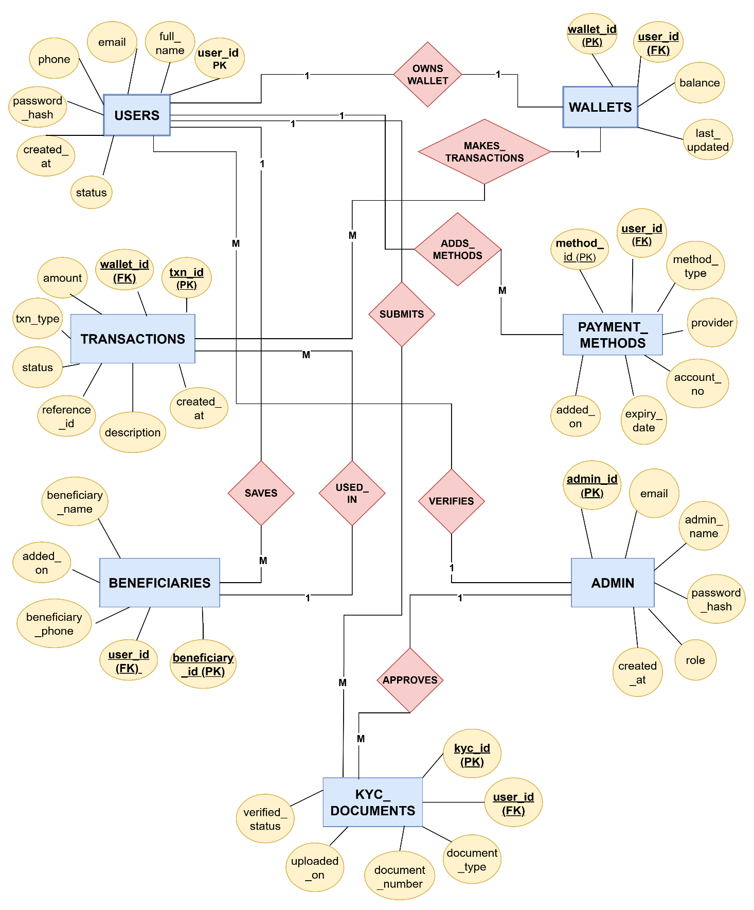
ER DIAGRAM:

RELATIONAL SCHEMA

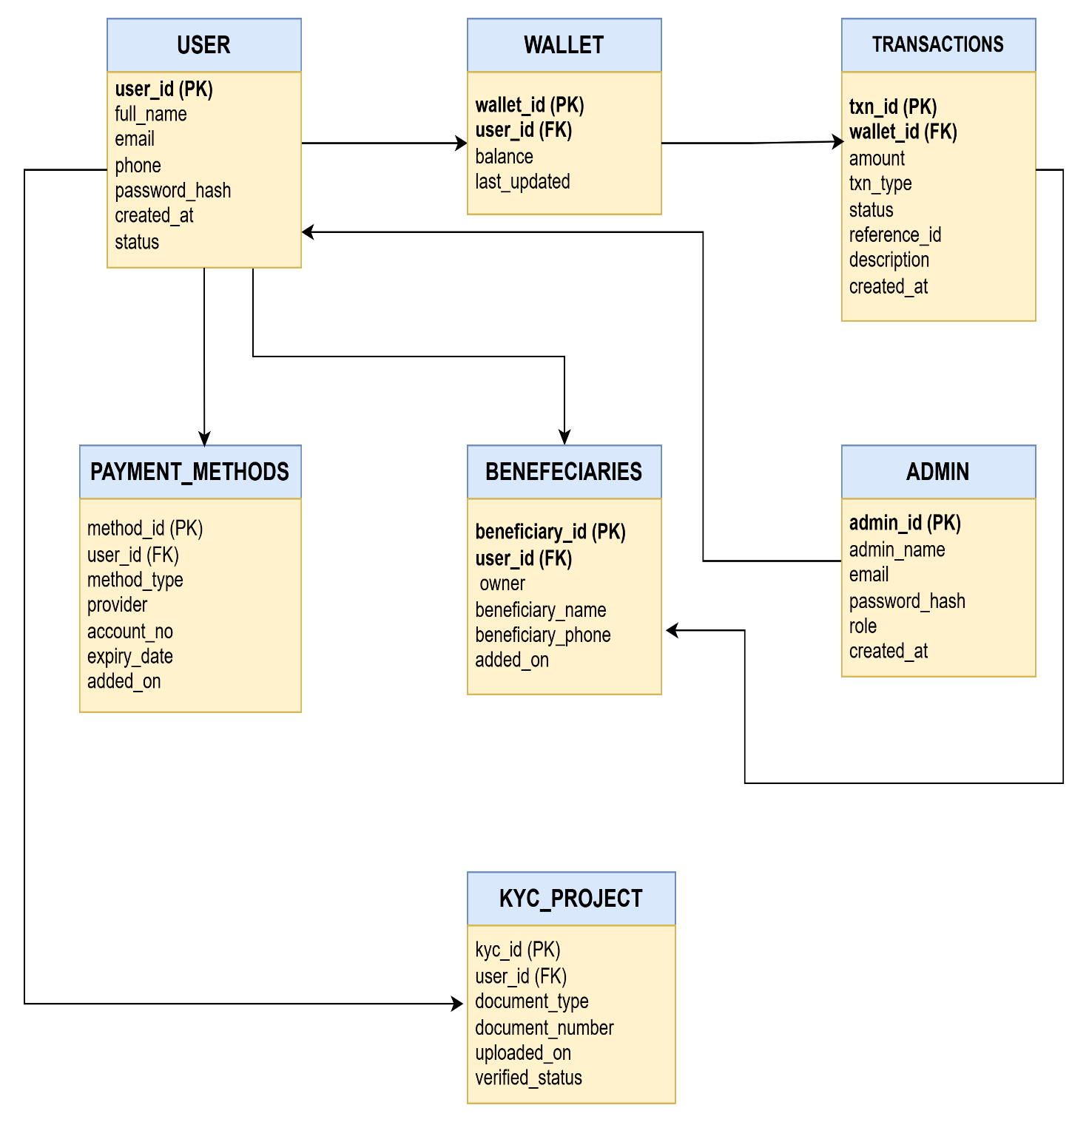

- User(UserID PK, FullName, Email, PhoneNumber, Password, CreatedDate)
- Wallet(WalletID PK, UserID FK, Balance, LastUpdated)
- Beneficiaries(beneficiary_id (PK),user_id (FK), beneficiary_name, beneficiary_phone, added_on)
- PaymentMethod(MethodID PK, UserID FK, MethodType, ProviderName, AccountReference)
- Transaction(TransactionID PK, WalletID FK, MerchantID FK, OfferID FK, Amount, Type, Timestamp, Status, ReferenceCode)
- Admin(AdminID PK, Name, Email, Password, Role)
- KYC_document(kyc_id (PK), document_type, document_number, uploaded_on, verified_status)

